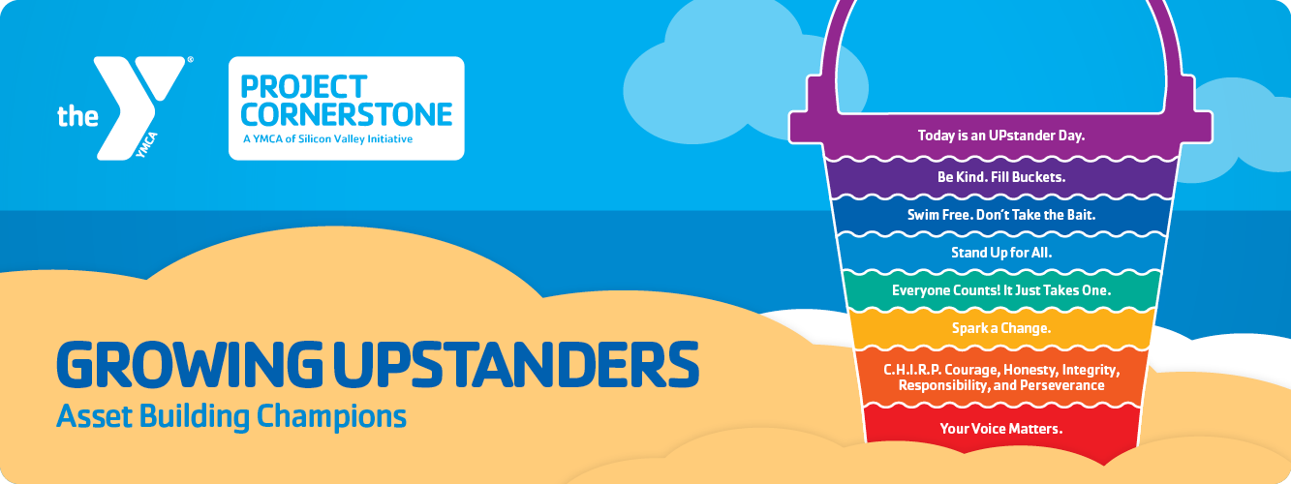



This month, your student read one of three books by Carol McCloud: Have You Filled a Bucket Today?, Buckets, Dippers, and Lids, or Growing Up with a Bucket Full of Happiness.

These books all use the idea of invisible buckets to show how our actions affect ourselves and others. Kind words and helpful deeds fill people's buckets with happiness, while mean words and actions dip from their buckets and make them sad. The books also talk about using a "lid" to protect your own happiness by not letting unkind things bother you too much.

This foundational concept promotes positive relationships and fosters a sense of belonging, creating a foundation for children to feel valued and supported.



When talking with your child about their day, use Bucket filling words and phrases, such as, “How did you fill someone’s bucket today?” or “Who’s bucket will you try to fill tomorrow?” The more you can focus on the positive, and reaffirm the language used at school, the more respectful and caring school environment we can create!

Encourage Bucket Filling at home with kind deeds and words. Help your student have a full bucket by telling what you appreciate and enjoy about them. 10-15 minutes a day of interrupted time with your student can make a big difference in their self-confidence.



With these imaginary buckets, each person’s is filled with happy feelings like joy and excitement. When we are kind to others, we fill up our bucket and the other person’s bucket too. Win-Win! But if we are unkind, it’s like taking some of the good stuff out of both buckets. That’s why being kind is so important!

At school, we’re teaching your child how to be a “bucket filler.” We help them learn how to make others feel happy and supported. Strong developmental relationships with caring adults act as reliable bucket fillers for children, fostering their emotional well-being and social-emotional learning.



* Grades K-2: “The Kindness Book” by Todd Parr \*Build emotional vocabulary and focus on simple, concrete examples
* Grades 3-4: “Kindness is My Superpower” by Alicia Ortego \*Encourage empathy and explore different perspectives
* Grades 4-6: “Wonder” by R.J. Palacio \*Discuss social issues and encourage critical thinking and compassion