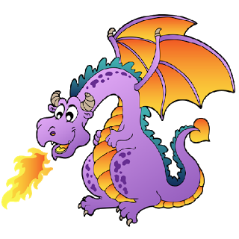  Take a breath and cool down. |  | Take a breath and cool down. |  | Take a breath and cool down.
Take a breath and cool down. |  | Take a breath and cool down. |  | Take a breath and cool down.
Take a breath and cool down. |  | Take a breath and cool down. |  | Take a breath and cool down.
Take a breath and cool down. |  | Take a breath and cool down. |  | Take a breath and cool down.
Take a breath and cool down. |  | Take a breath and cool down. |  | Take a breath and cool down.
Take a breath and cool down. |  | Take a breath and cool down. |  | Take a breath and cool down.
Take a breath and cool down. |  | Take a breath and cool down. |  | Take a breath and cool down.
Take a breath and cool down. |  | Take a breath and cool down. |  | Take a breath and cool down.
Take a breath and cool down. |  | Take a breath and cool down. |  | Take a breath and cool down.
Take a breath and cool down. |  | Take a breath and cool down. |  | Take a breath and cool down.

