

**The *UPstander* Triangle**

**Bystander?**

**or**

***UPstander*!**

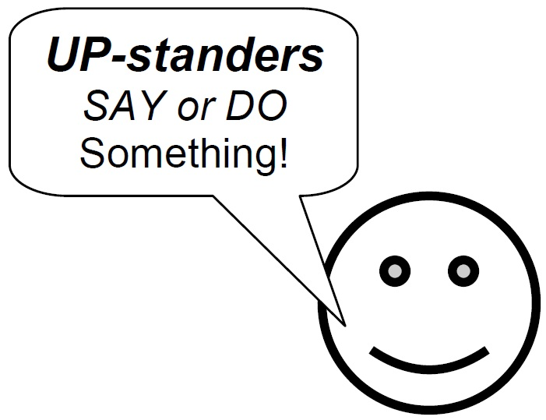

***UPstanders***

*SAY or DO*

Something!

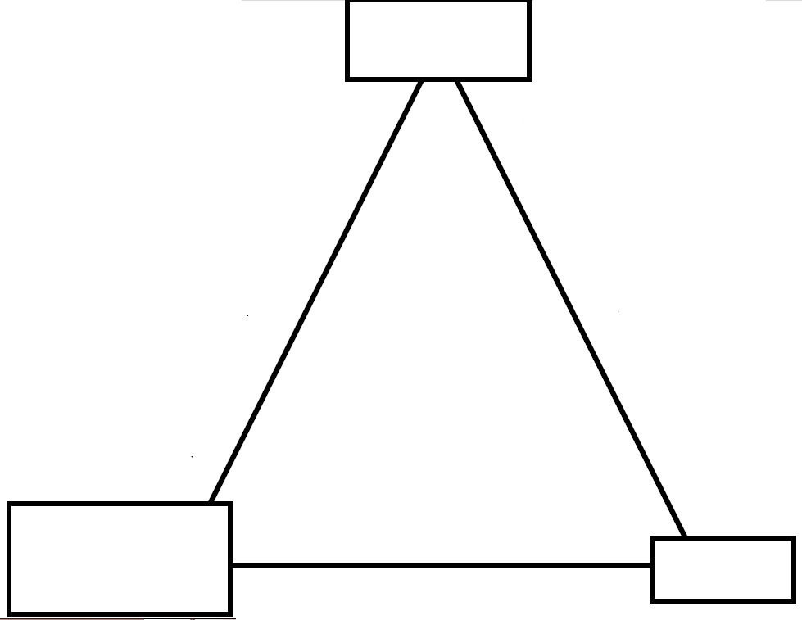

***Influence***

***Support***

***dip***

**Person with**

**low bucket**

*(bucket dipper)*



**Target**

