**CORNERSTONE CORNER**

UPSTANDER PLEDGE

I am an UPSTANDER.

I have the power

to influence my peers.

I SAY something or DO something

When you need help.

I am there for you.

I will help you get

the help you need.

You are not alone.

I have your back.



This Month’s Book:*One by Kathryn Otoshi*

In your child’s classroom, we read the book *One* by Kathryn Otoshi. According to Otoshi, “How one voice can count and affect change. Many times we think, ‘I'm so small. What can I do?’ But we do have an effect! It's about changing thinking. When one person stands up for something, it might be just enough to tip the next person over and inspire him or her to also stand up.”

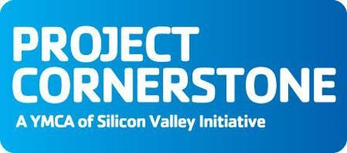*One* helps students recognize that they have the power to effectively react and respond to bullying behaviors. The key messages are “***Everyone counts”*** and ***“It just takes one to make a difference.”***

**Bystanders**

**vs**

**UPSTANDERS**

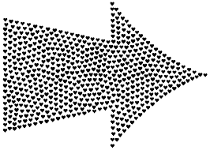We also discussed the difference between passive *bystanders* and proactive ***UPstanders*.** Bystanders can become ***UPstanders*** by*saying or doing* something to support targets of bullying. ***UPstanders*** know that *it just takes ONE to make a difference.* ***UPstanders*** take action to influence others to stop hurtful behavior.

WHAT CAN

WE DO AT

* Talk about ways that each family member *counts*!
* Role-play ways to de-escalate conversations using a calm tone of voice, positive words, and comforting body language.
* Practice ways to *stand tall* using positive body language.

Here are some ways that we all can be

home?

***UPstanders*** at home and in our communities:

🞏 Refuse to join-in with bully behaviors.

🞏 Use positive peer influence to help friends “do the

right thing”.

🞏 *Say or do* something when someone needs help. (Just

standing near someone will make him/her feel better!)

🞏 Help all kids join the fun. Invite someone new to play!

🞏 Use body language to *stand tall!*

🞏 Use the ability to read body language to *de-escalate*

conflict and keep things calm.

🞏 Laughing and joking with friends is fun, but laughing

*at* a friend is hurtful.

🞏 Help kids “save face” when they are in a tough spot.

🞏 ***Always*** get an adult if you need help especially if

there is violence or a weapon!

On the back of this letter is the It Just Takes One

handout for you and your child to do together.

APRIL 2019 Article 7 Reader: __________________________ email: ______________________________________________