<TEACHER’S NAME> Bucket Filling Class Name:
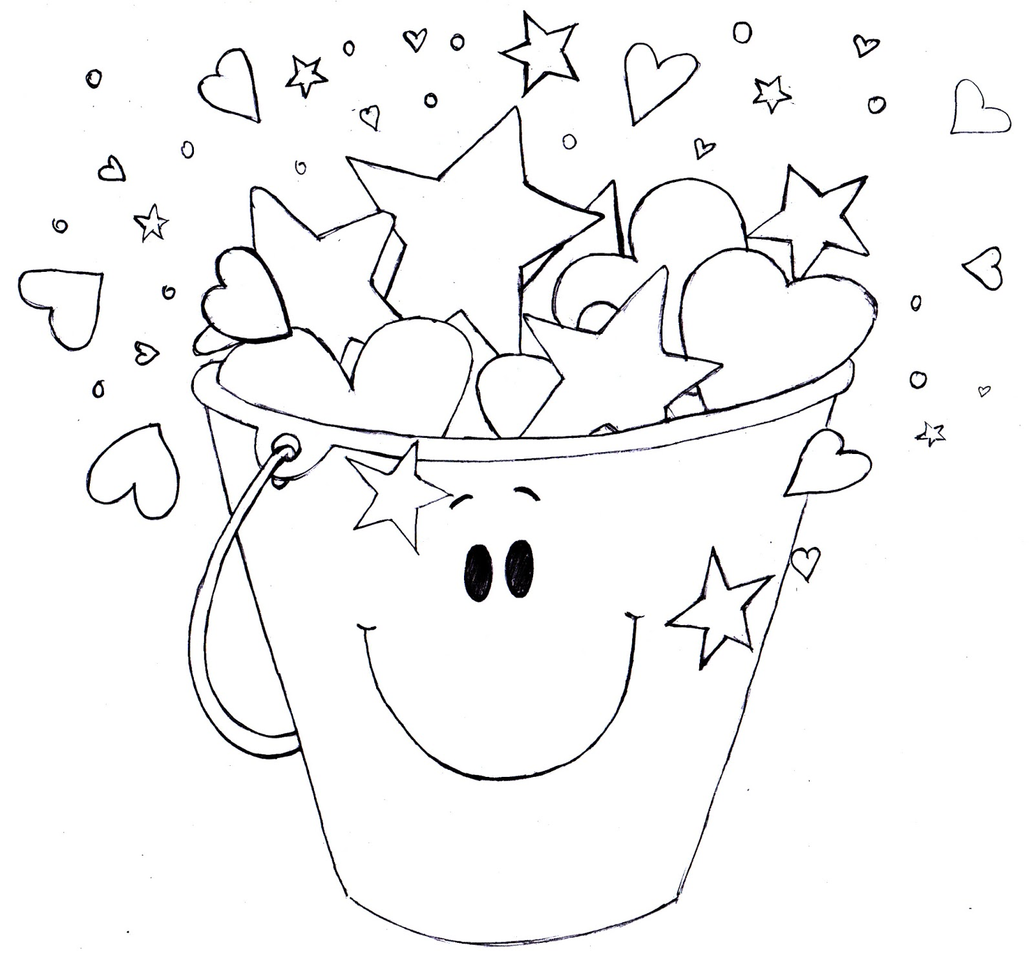
I Fill Buckets When I

